Expression Add Operators
Problem Statement: Given a string num that contains only digits and an integer target, return all possibilities to insert the binary operators '+', '-', and/or '*' between the digits of num so that the resultant expression evaluates to the target value.
Note that operands in the returned expressions should not contain leading zeros.
Note that a number can contain multiple digits.
Examples
Example 1:
Input: num = "123", target = 6
Output: ["1*2*3","1+2+3"]
Explanation:Both "1*2*3" and "1+2+3" evaluate to 6.

Example 2:
Input: num = "232", target = 8
Output: ["2*3+2","2+3*2"]
Explanation:Both "2*3+2" and "2+3*2" evaluate to 8.
Algorithm
Use backtracking with Depth-First Search (DFS) to solve the problem by exploring all possible expressions.
For each digit in the input string, add one of the three operators (+, -, *) and recursively explore the expressions.
Track the current expression and evaluate its result step by step.
Key Considerations:
Leading Zeros: Ensure valid numbers do not have leading zeros unless it's the number "0".
Operators: Add one of the three operators (+, -, *) between digits and recursively check all combinations.
Operand and Target Evaluation: At each recursion step, calculate the current value based on the operators applied, and continue until the full string is consumed.
Recursive DFS Function:
Current Index (start): This tracks the position in the string num that we are currently working on.
Current Expression (expr): This keeps track of the current mathematical expression as a string.
Current Value (current_value): The result of the expression calculated so far.
Previous Operand (last_operand): The last number added to the expression, used for multiplication handling since multiplication has higher precedence than addition and subtraction.
Base Case:
When the end of the string is reached, check if the final result equals the target.
Recursion Logic:
Start at the first character and try all substrings that form valid numbers.
For each valid substring, call the DFS function with the new expression formed by adding an operator.
Once the end is reached, evaluate if the expression evaluates to the target.
Avoiding Leading Zeros:
If a number has multiple digits and the first character is '0', skip it as it's an invalid number.
Final Expression:
Once the recursion reaches the end, check if the evaluated expression matches the target value.
If valid, add it to the result list.
Return Results:
After all recursive calls, return the list of valid expressions that evaluate to the target.
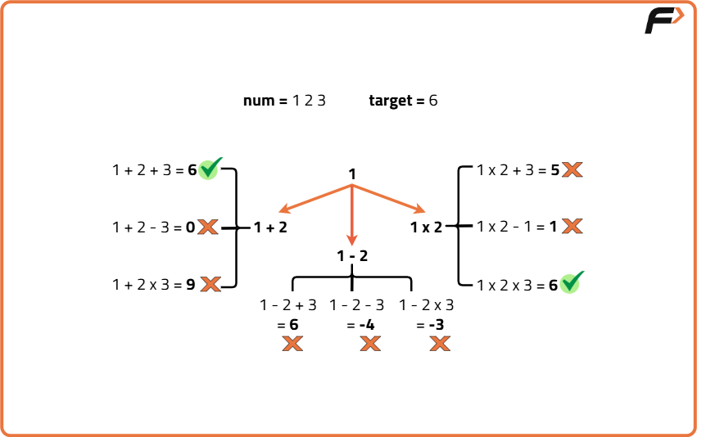
Code
import java.util.List;
import java.util.ArrayList;

class Solution {
// Function to evaluate the expression
public void dfs(String num, int target, int start, long current_value, long last_operand, String expression, List<String> result) {
// Base case: If we've reached the end of the string
if (start == num.length()) {
// If the expression evaluates to the target, add it to result
if (current_value == target) {
result.add(expression);
}
return;
}

// Loop through all substrings starting from 'start' index
for (int i = start; i < num.length(); i++) {
// Skip leading zeros in numbers
if (i > start && num.charAt(start) == '0') return;
// Get the current number
String current_num = num.substring(start, i + 1);
long current_num_val = Long.parseLong(current_num);

// If we are at the first number, just start the expression
if (start == 0) {
dfs(num, target, i + 1, current_num_val, current_num_val, current_num, result);
} else {
// Add the current number with '+'
dfs(num, target, i + 1, current_value + current_num_val, current_num_val, expression + "+" + current_num, result);

// Add the current number with '-'
dfs(num, target, i + 1, current_value - current_num_val, -current_num_val, expression + "-" + current_num, result);

// Add the current number with '*'
dfs(num, target, i + 1, current_value - last_operand + last_operand * current_num_val, last_operand * current_num_val, expression + "*" + current_num, result);
}
}
}

public List<String> addOperators(String num, int target) {
// To store the valid expressions
List<String> result = new ArrayList<>();
// Start DFS with empty expression
dfs(num, target, 0, 0, 0, "", result);
return result;
}
}
Time Complexity: O(4^n), since in each recursive call, we can choose 4 possibilities for each substring (three operators: +, -, *, or no operator in the case of the first number), resulting in an exponential time complexity with a branching factor of 4.
Space Complexity: O(n), since the space complexity is dominated by the recursion depth, which can go as deep as the length of the string. Additionally, we store the result expressions in a list, but this doesn't increase the space complexity beyond the recursion stack and the input size.

